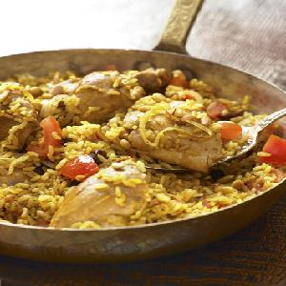

**Chicken Pilau**

Ingredients:

* *2 tb Oil*
* *1/2 c Butter Chicken pieces (4-6)*
* *1 lg Onion; sliced*
* *1 c Chopped dried apricots*
* *1/2 ts Cinnamon*
* *1 Orange skinned rind;*
* *Salt and pepper to taste*
* *1 cup Plain yogurt*
* *1 1/2 c Long grain rice*
* *2 tb Slivered almonds*

Method:

1. *Heat oil and 2 tablespoons butter in large, deep skillet.*
2. *When butter is foaming, cook chicken pieces until golden brown.*
3. *Remove from pan and let cool.*
4. *Add onion to pan and sauté until golden.*
5. *Add apricots; sprinkle with cinnamon, orange rind, salt and pepper.*
6. *Remove bones from chicken pieces and shred meat.*
7. *Mix yogurt with onion mixture.*
8. *Cover shredded chicken with yogurt mixture and set aside for 20 minutes.*
9. *Cook rice in boiling salted water 10-12 minutes.*
10. *Drain and rinse with boiling water.*
11. *Let dry for 3-4 minutes.*
12. *Heat 3 tablespoons butter in heavy pan or casserole dish.*
13. *Stir half of the rice into pan.*
14. *Pour chicken mixture over rice, then cover with remaining rice.*
15. *Season with salt and pepper.*
16. *Preheat oven to 350°.*
17. *Melt 2 tablespoons butter and spoon over rice.*
18. *Cover pan and bake 15-20 minutes.*
19. *Brown almonds in remaining butter. Sprinkle on top of rice and serve immediately.*

Enjoy this lovely meal.